Vision Timesheets

# How to Enter Timesheets:

* Vision
* Time & Expense
* Timesheet

1. You will record **ALL** hours worked on your timesheet.
2. Your timesheet should always open to the current period.
3. To enter your time worked on a project, click the magnifying glass in the corner of the first available project box. A project lookup will appear like below:

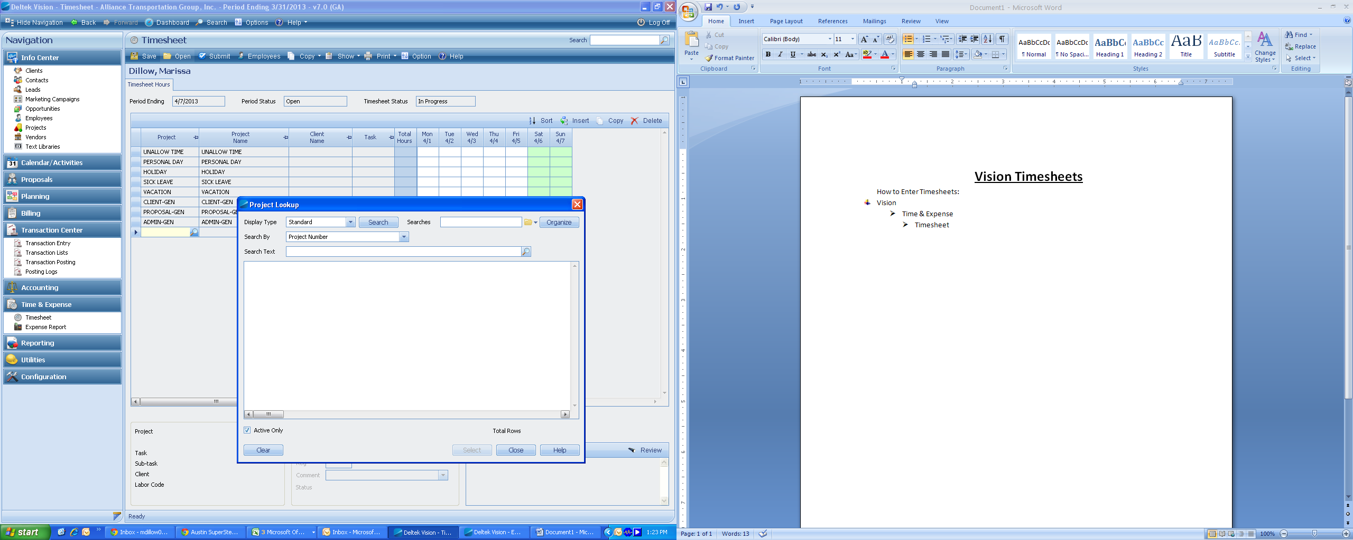

* Highlight the correct project and click “select”

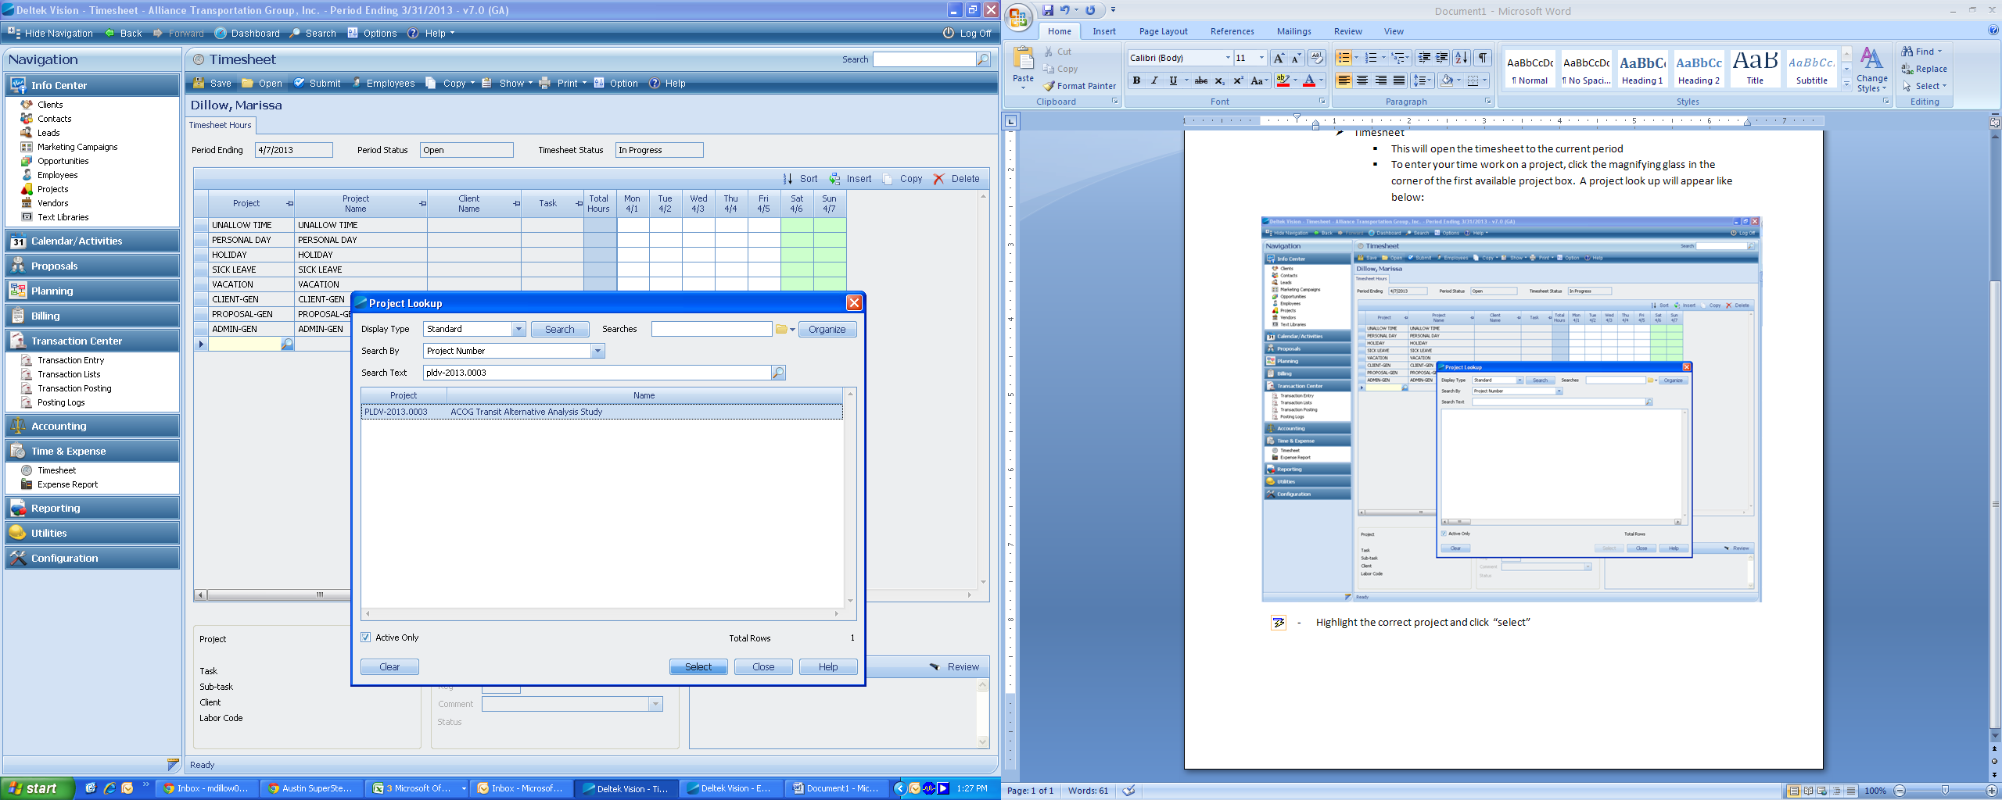

* The “Project Name” and “Client Name” will auto-fill from the project you’ve chosen.
* Task Selection:
* To choose the correct labor task hit the search button in the task line to view all available tasks for the project.
* **NEVER charge your time to any task that has the word “EXPENSE” in it!**

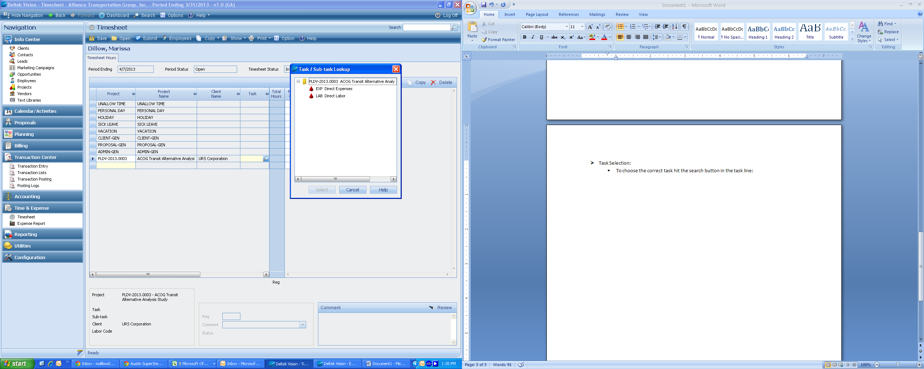

* Make sure when choosing your tasks you **KNOW** specifically what you worked on. The Project Manager or Division Manager should tell you exactly what task to charge to if you are unsure.
* Once you’ve chosen the task, record your hours under the appropriate date.
* When recording your time in OH Accounts (ADMIN-GEN, PROP-GEN, CLIENT-GEN, or PTO) - all hours in OH accounts require comments before you can save your timesheet. Do not record comments for direct projects (EGDV, PLDV). For OH Accounts, please choose a pre-filled comment from the drop down box- Comments are only required for time charged in Overhead Accounts (Indirect Labor): 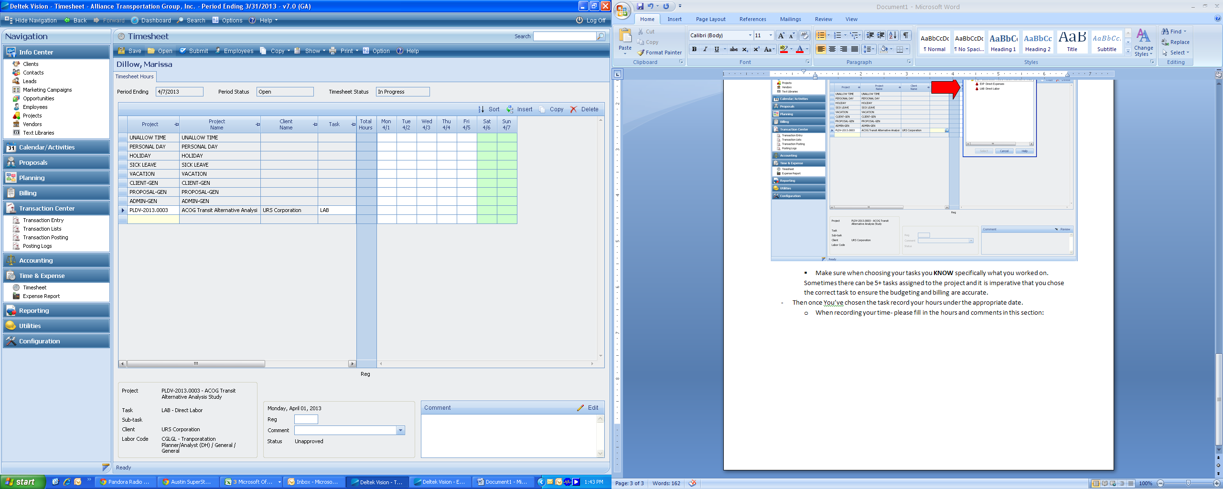

Timesheets must be filled out DAILY

Timesheets are due (submitteD IN VISION) every Friday at the close of business (or by sunday evening if working the weekend)

* To submit your timesheet for approval:
* Once your 40 (+) hours are recorded click on the “SAVE” Icon and then “SUBMIT”
* You must enter your Vision password to submit your timesheet

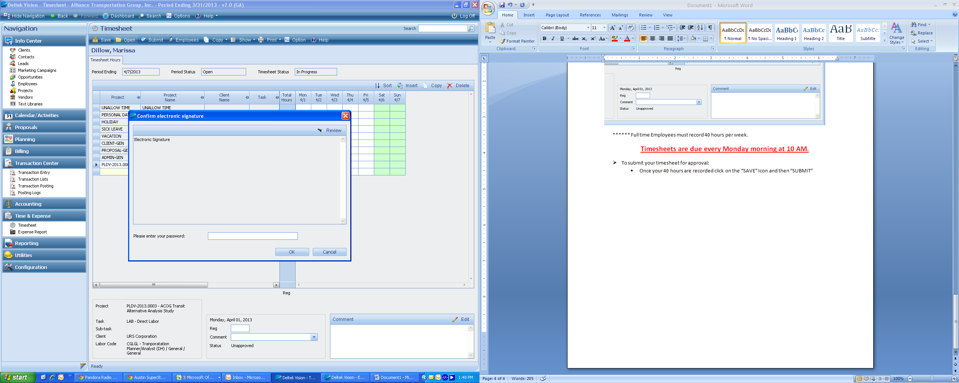

* Once you’ve entered your password you must ***CLICK*** “OK”. Hitting enter will not submit your timesheet.

Once you’ve submitted your timesheet, you can only make changes until the timesheets are posted. You can tell the status of your timesheet (In Progress, Accepted, Posted) by choosing “Open”

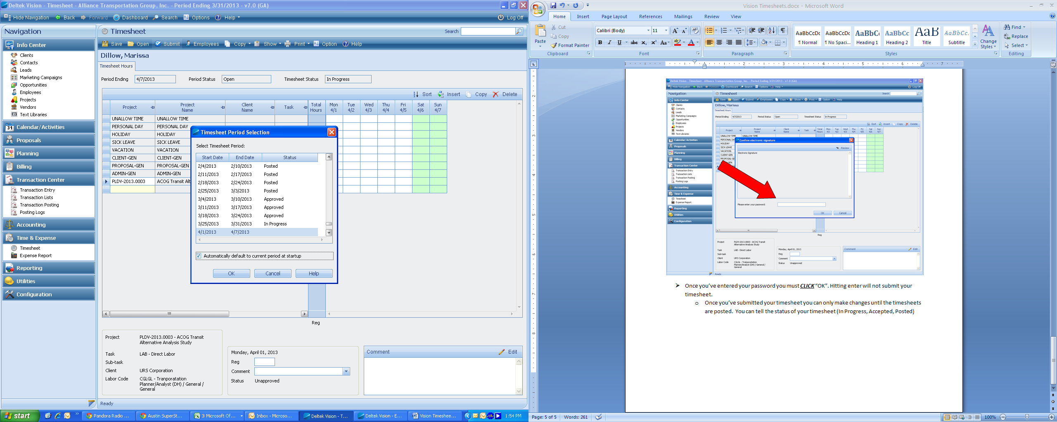

* If you make any changes to your timesheet- you must submit the timesheet again